Final Report

Elijah Reyna and Dylan Stephens
Data Mining Spring 2025
The University of West Florida

4/25/25

CAP4770 Data Mining
Dr. Shashi Bhushan Jha

Table of Contents
Table of Contents 2
Table of Contents 2
List of Figures 3
1 Introduction 4
2 Background 4
3 Our Database and Data 4
4 Exploring the Data 5
4.1 Exploring Correlations 5
4.2 Exploring Targets 5
5 Our Model 6
5.1 Targets 6
5.2 Evaluation 6
5.3 Results 6
References 8

List of Figures
Figure 1: Top 15 Features for ‘positivity_ratio” 7
Figure 2: Top 15 Features for Positive Reception 8

1 Introduction
For this project, we aimed to build a model that would predict user reception of video games based on tags, genres, publishers, etc. We pulled from the Steam Games Dataset in Kaggle (Fronkon Games 2022) and successfully built a model that could predict how well a game would do, from a user reception lens. We then pulled the most influential features to see which ones had the greatest effect on how a game was received by the public.

2 Background
It is important for game developers to build games that users want to play. But there are many variables that go into it. By discovering which features influence how much a game is enjoyed, developers can focus on the features that will have the most impact on how their game is received.

3 Our Database and Data
We decided to use MongoDB for our database, as we had a lot of practice using it for another project. Here you can see where we load the games.json file into a local database:
FIXME: Image of where the data is loaded into the database
Here is where it is loaded from the database and preprocessing is done
FIXME: Image of preprocessing code
As part of the data cleaning process, we did the following:
- Removed outlier data
FIXME: Outlier removal algorithm and a picture of it
- Created two attributes base on positive reviews and negative reviews:
  - Net sentiment: positive – negative
  - Positivity ratio: positive / (positive + negative + 1)
- Converted required age -> age requirement (0 or 1)
- Binarized categories, tags, and developers using MultiLabBinarizer
- Converted full_audio-languages to 0 or 1
- Converted supported_languages to a number value

4 Exploring the Data
We explored the steam games dataset, which had over 97,000 entries. With all that data, we felt sure we could find some meaningful connections between features and user reception.

4.1 Exploring Correlations
One of the first things we did was look at how certain features influenced the number of positive reviews a game got.
FIXME: Images of the correlations of each feature to positive reviews
Some of these make sense. Linux games having a positive reception is likely due to how games that are built in linux reach a wider audience. The same thing goes for those with language support for many different languages

4.2 Exploring Targets
User reception is complicated. A game can be highly rated among three people, or it can be popular, but with a lot of negative reviews. We wanted to get a good picture on how a game did, so we ended up with five targets: positivity_ratio, net_sentiment, positive_reviews, negative_reviews, and estimated_owners.

5 Our Model

5.1 Targets
We decided to predict 5 targets simultaneously, being positivity_ratio, net_sentiment, positive_reviews, negative_reviews, and estimated_owners. As mentioned above, we felt that these targets would give us a good picture on how well a game is doing.
We extracted feature importances from each Random Forest model, with Positivity_ratio, net_sentiment, positive_reviews, and estimated_owners having a positive weight, and negative_reviews having a negative weight. We calculated a composite score for each feature across all targets and sorted features by total score to find the Top 15 predictors

5.2 Evaluation
We decided to use Mean Absolute Error, Root Mean Squared Error, and Explained Variance to evaluate our model. By using each of these metrics, we would be able to improve our model across a few different areas.

5.3 Results
For the greatest impact on positive reception, we found that the price, how prolific the developers are, and the number of supported languages were the features to focus on. Price is a feature that is obviously relevant. The cheaper the price is, the more people can play it, and the more positively they view the game. The more languages a game supports, the wider the audience will be. And how many other games the developers created is also a big factor, which also makes sense. A successful game company is only going to be successful if they develop engaging and fun games.
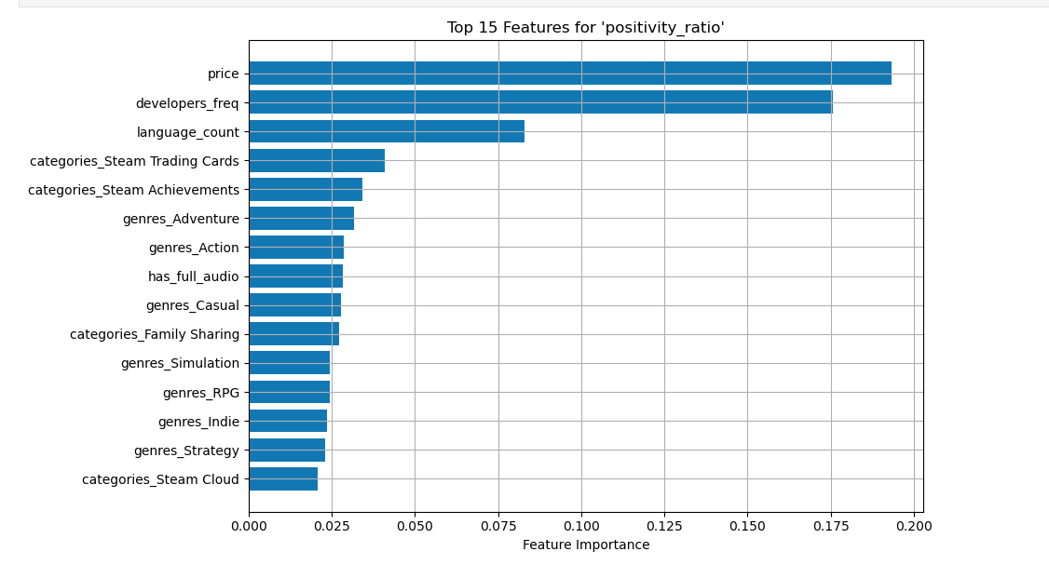
Figure 1: Top 15 Features for ‘positivity_ratio”

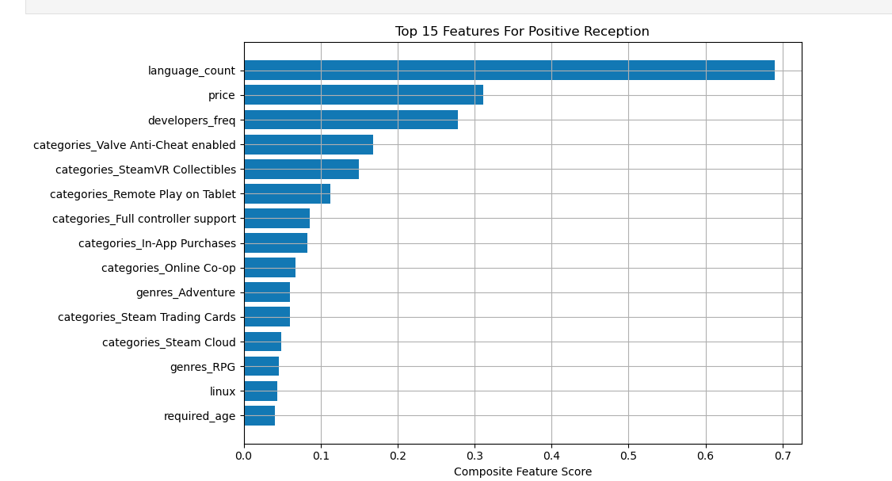
Figure 2: Top 15 Features for Positive Reception
FIXME: Any other results found

References
[1] Fronkon Games. 2022. Steam Games Dataset. Kaggle. https://www.kaggle.com/datasets/fronkongames/steam-games-dataset.

